Data logger Manual

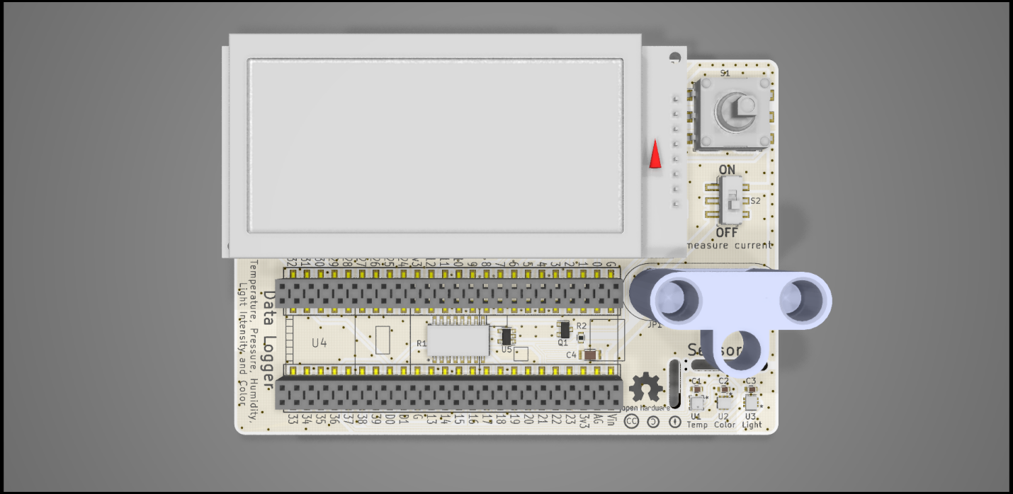

Board ordering

To build the data logger, you will need a PCB board. To greatly ease assembly, you will also want a solder paste stencil. Both of these can be easily ordered by submitting the Gerber files to a PCB and stencil fabricator. Several such vendors include Aisler, PCBWay, JLCPCB, etc.

Board specifications:

Size: 69 x 100 mm

Board: 1.6 mm FR4

Copper : 1 oz/ft2

Surface finish: HASL with lead or ENIG

Vias: Tented

Stencil specifications:

Type: Non-framework (unless you have a stencil printer: <http://www.madelltech.com/m2-4.html>)

Electropolishing: Yes (this is essential to prevent the solder paste from sticking onto the stencil)

Parts ordering

Parts can be easily ordered by submitting the bill-of-materials ([Data logger BOM.xlsx](https://github.com/Llamero/Light_Color_and_Intensity_Datalogger/blob/master/Data%20logger%20BOM.xlsx)) to any major parts vendor including Digikey (<https://www.digikey.com/bom>) or Mouser (<https://www.mouser.com/bom/>). The BOM is setup to automatically calculate the number of parts needed based on the number of boards specified.

Equipment needed:

Tape

Single edge razor blade

Disposable stirrer (pipette tips work well)

Soldering iron

Solder

Solder paste

Solder flux

Magnifying glass or microscope

Tweezers or forceps

Thermometer

Hot plate

Hot glue gun

Aluminum foil

Disposable latex or nitrile gloves

70% Ethanol or rubbing alcohol

Soldering the board

Before starting with assembly of the board be sure to read and understand all of the following instructions. Once the solder paste is applied the board must be reflowed within two hours or too much of the flux will evaporate. Also be sure to change your gloves regularly during the application of the solder paste. Solder paste can readily get into the skin, posing a health hazard. Hazards aside, assembling a PCB board is very much akin to building a model or advanced Lego® kit with no advanced skills required. Here is an additional tutorial on solder paste stenciling (<https://www.sparkfun.com/tutorials/58>) and reflow (<https://www.sparkfun.com/tutorials/59>).

# Step 1: Tape PCB boards together

You want to tape the board to another PCB board so that the stencil can be attached to a flat surface.

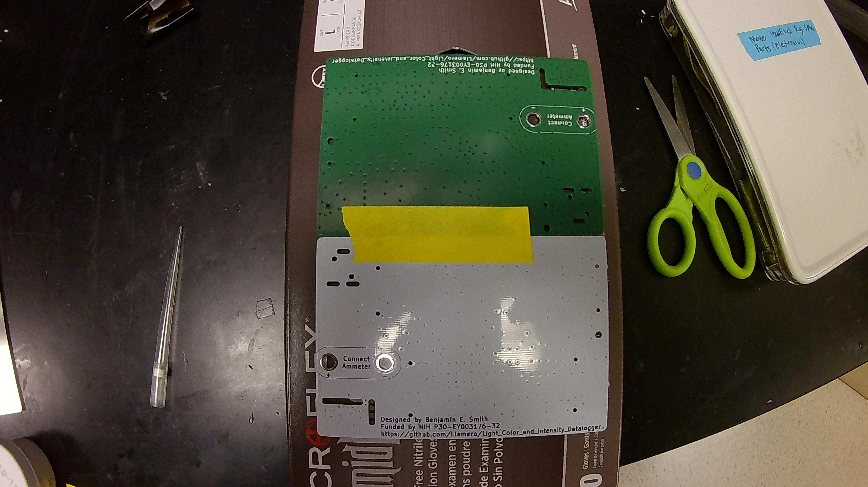

# Step 2: Align stencil onto PCB

Using a microscope or magnifying glass, try to align the stencil as accurately as possible with all of the stencil holes lining up with all of the PCB pads. Small errors (less than half a pad spacing) are tolerable as the solder will wick to the correct position, but the more aligned the better. The sensor pads are the most closely spaced, so be extra careful to align them properly.

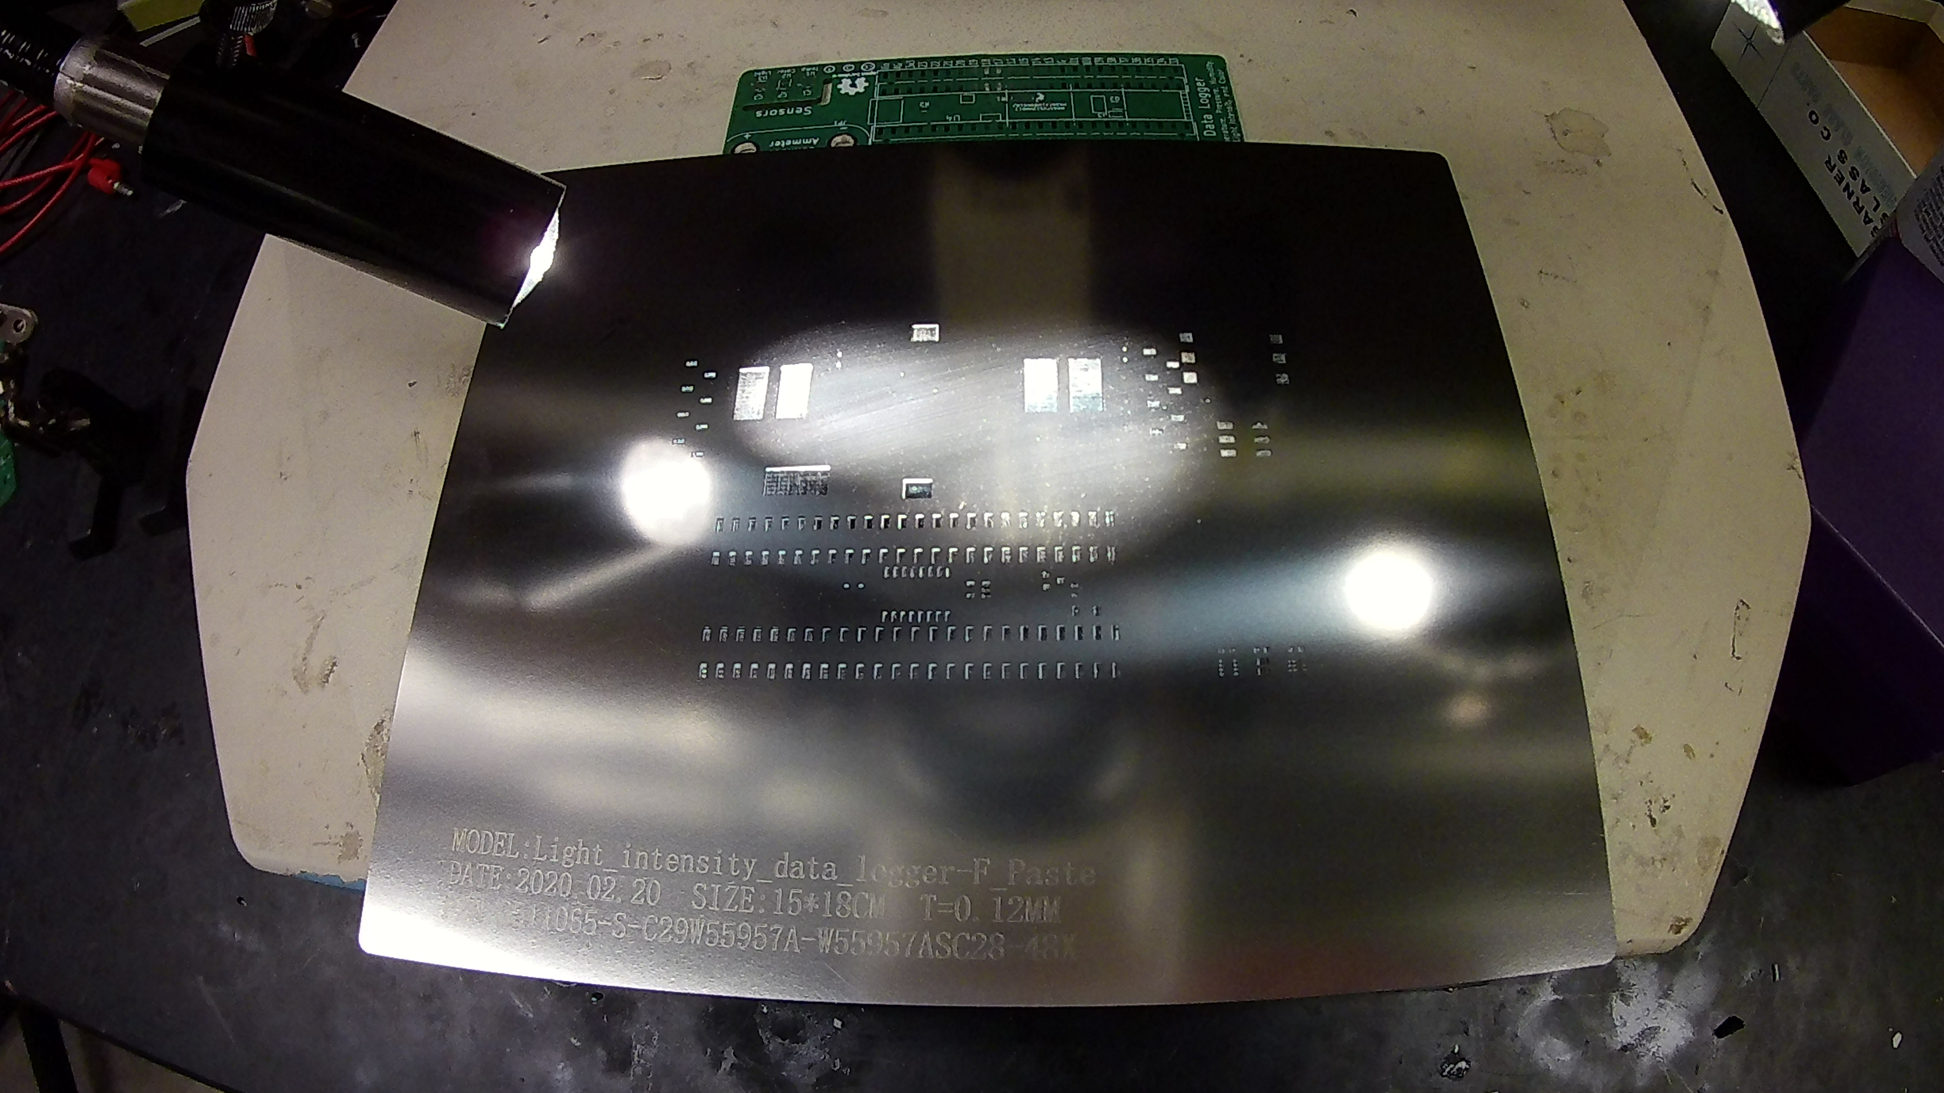

# Step 3: Tape stencil in place onto spare PCB

Carefully tape the stencil into place, and then press down the on the stencil to check the alignment. Repeat steps 2-3 if the stencil looks off center.

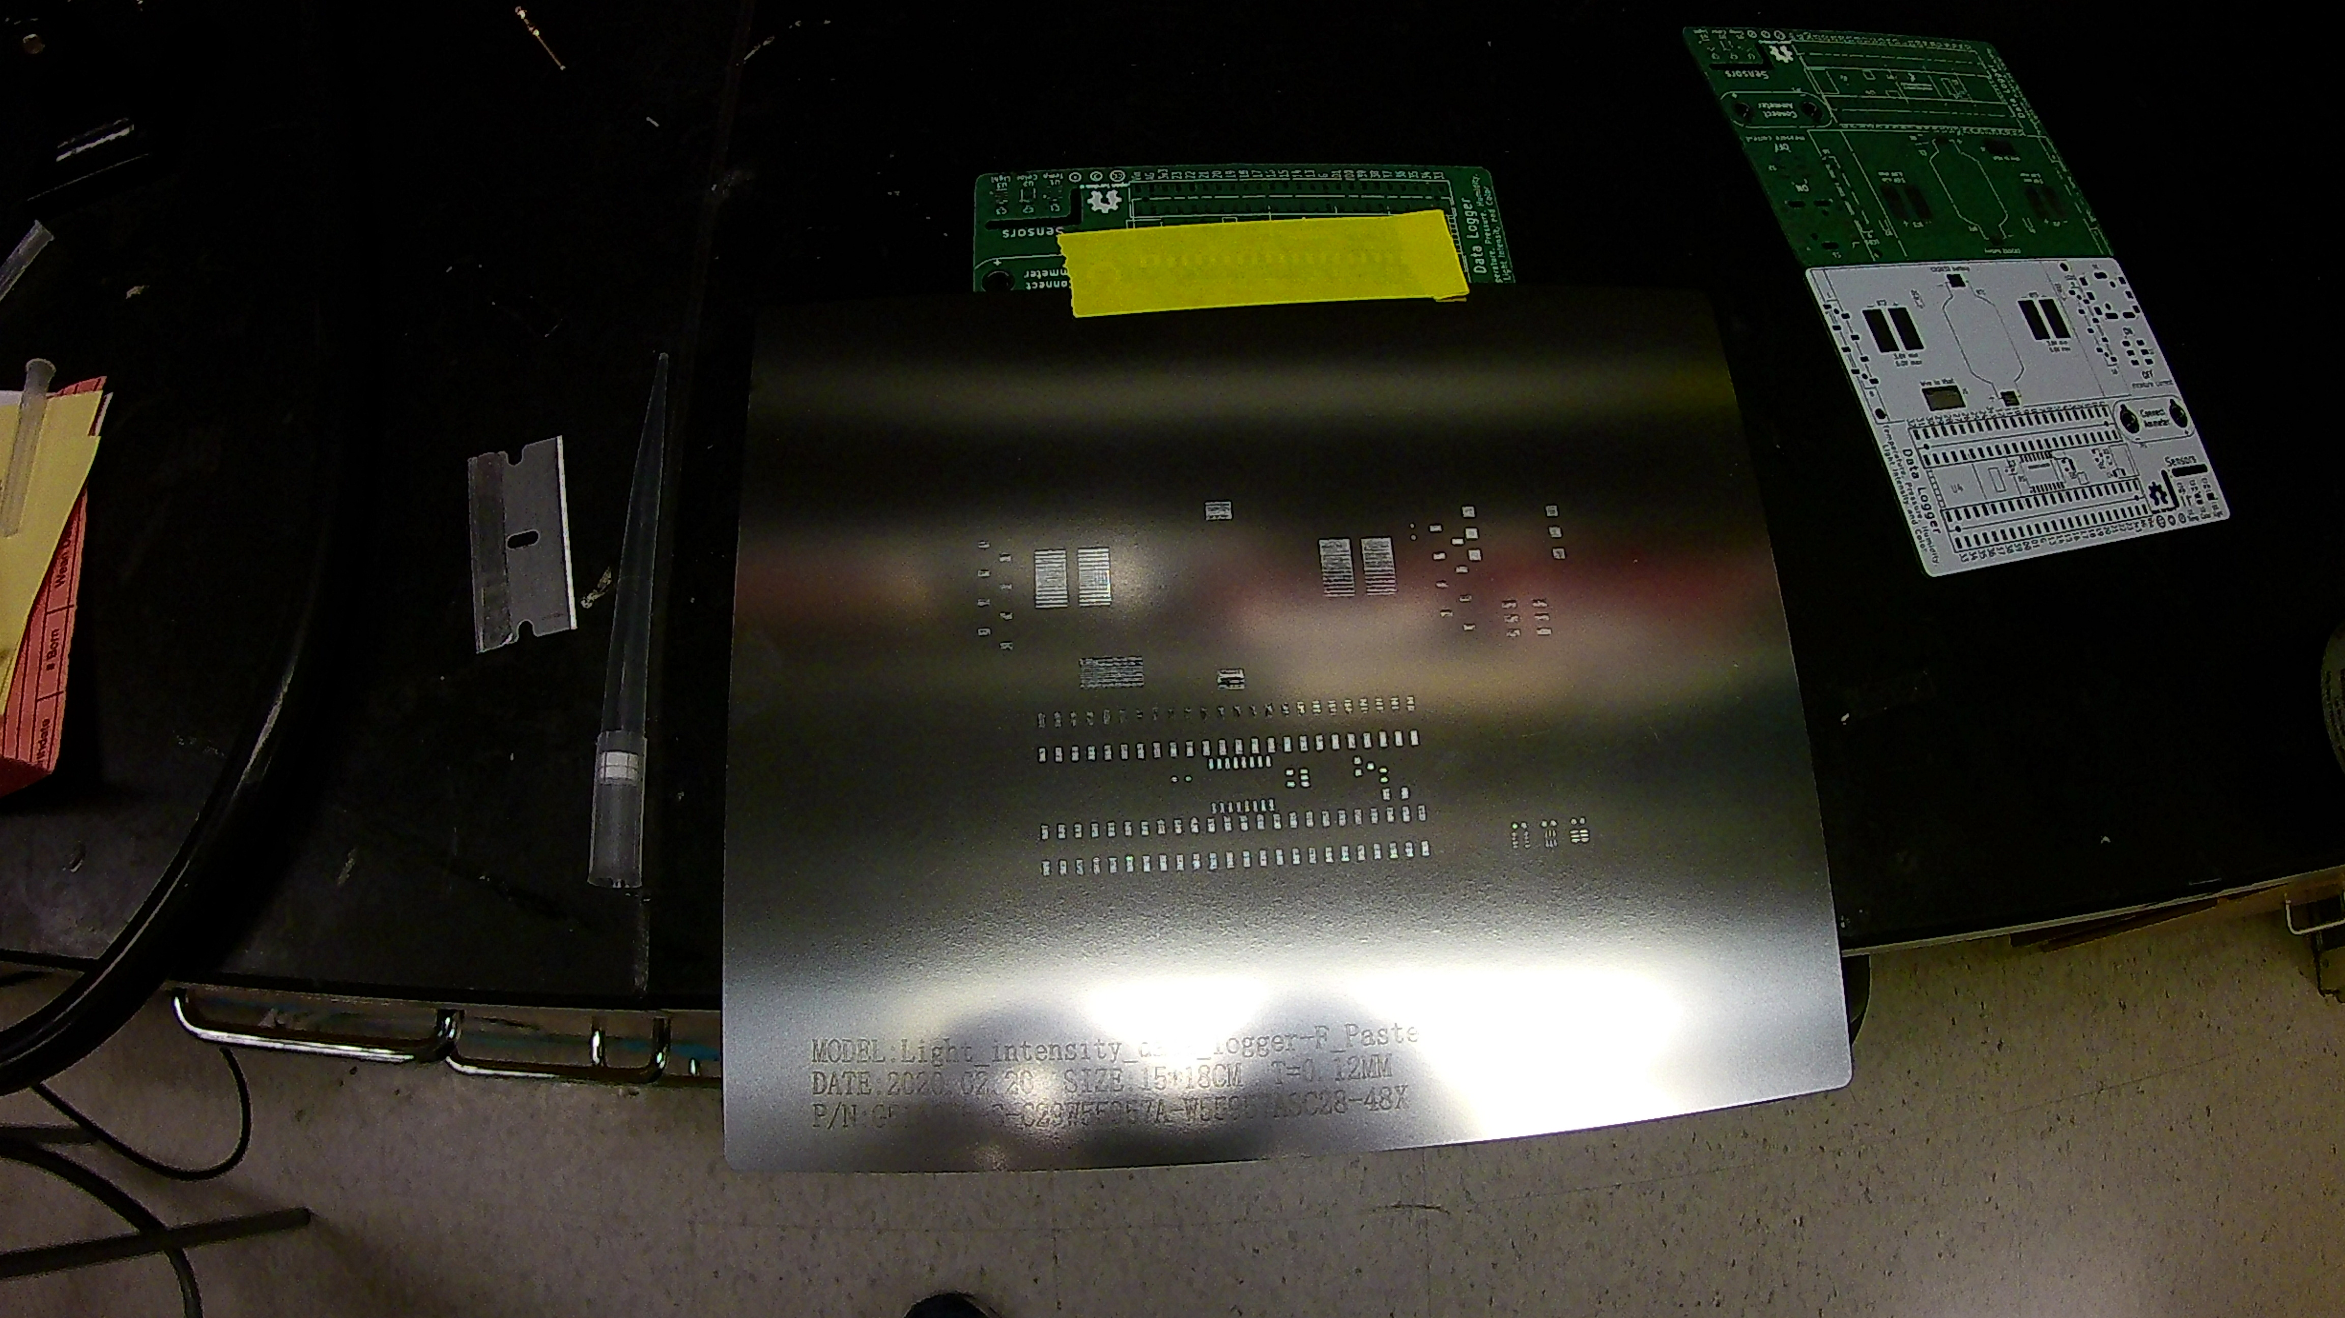

# Step 4: Thoroughly mix the solder paste

Put on a pair of disposable gloves and vigorously mix the solder paste with a disposable stirrer (such as a pipette tip) for at least one minute. Inadequately mixed solder paste can lead to poor solder reflow.

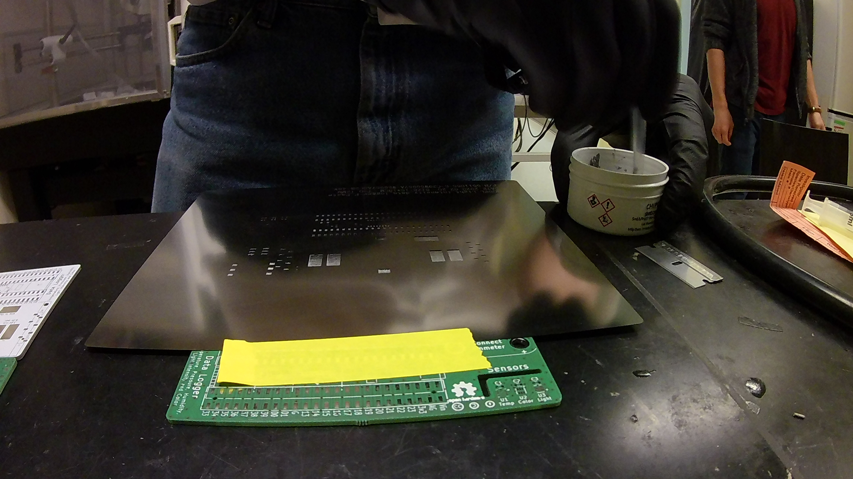

# Step 5: Apply solder paste to the razor blade

Using the stirrer to apply a generous amount of solder paste to the blade edge of the razor blade.

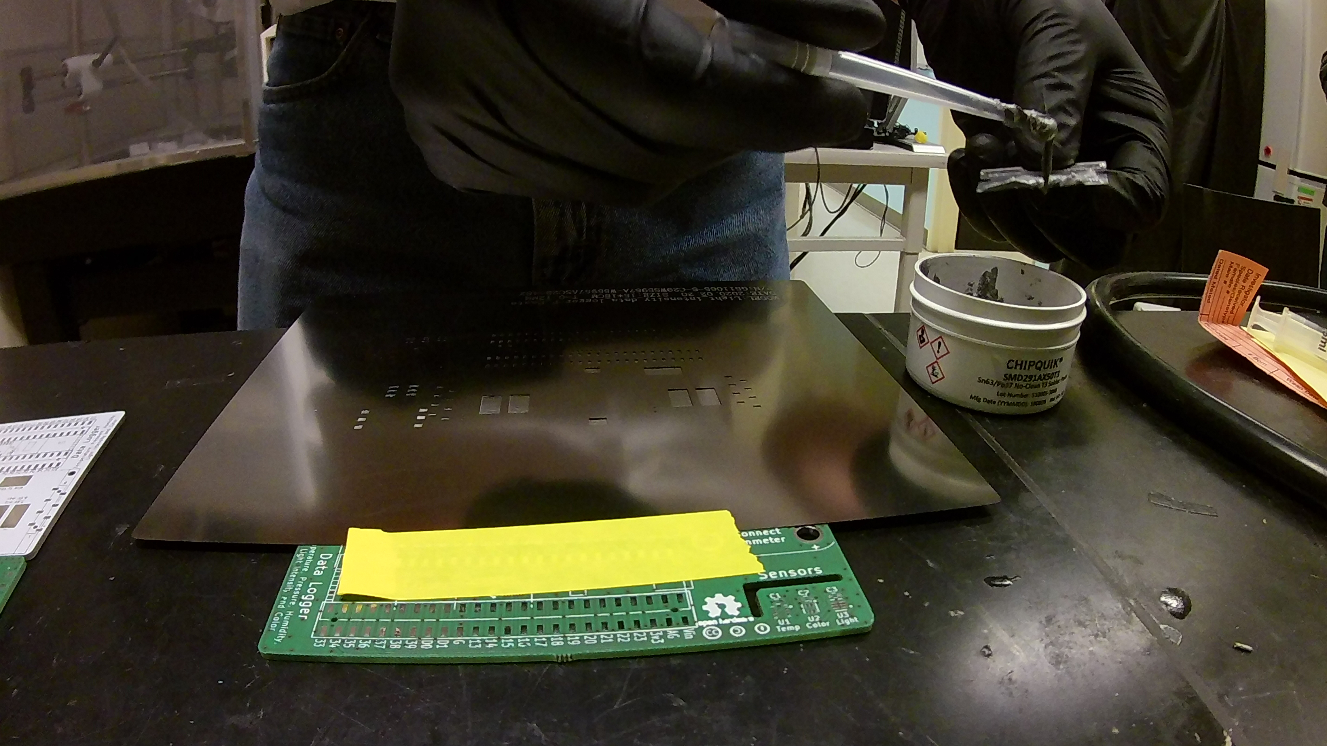

# Step 6: Apply thick layer of solder paste to the stencil

Use the razor blade to apply a coat of solder paste to the stencil, ensuring you cover all of the pads. Try to move across the stencil at a 45° angle to reduce the risk of pressing paste under the stencil. It will likely take multiple applications to cover the entire stencil.

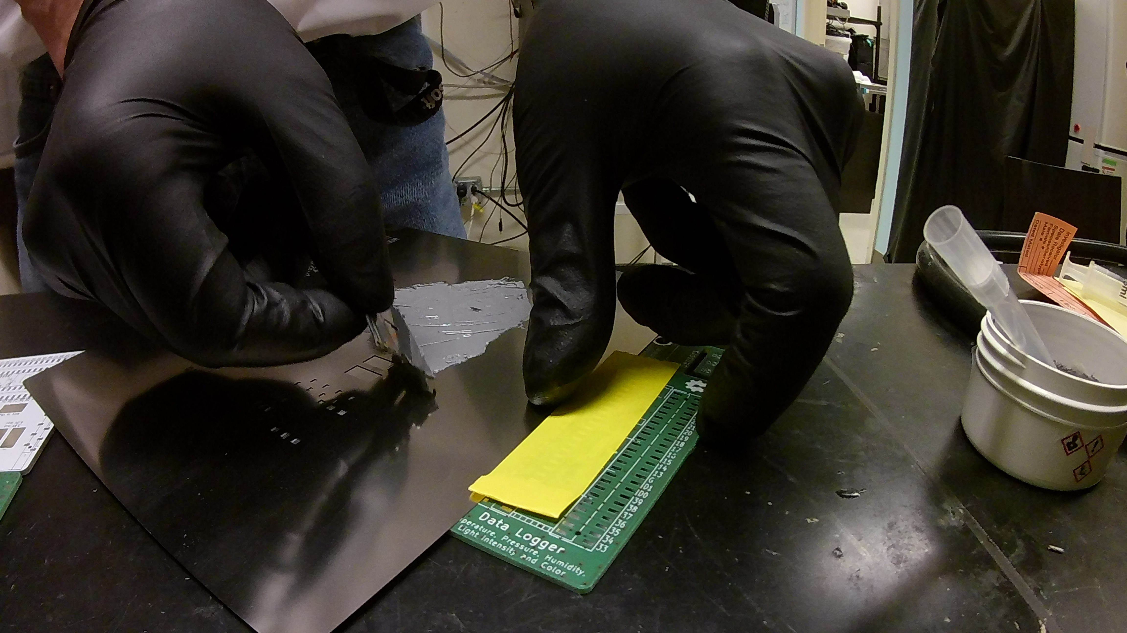

# Step 7: Remove all excess solder paste

Press the razor blade onto the stencil and carefully scrape off all of the excess solder paste. Use the stirrer to remove the excess paste from the blade and return it to the solder paste container.

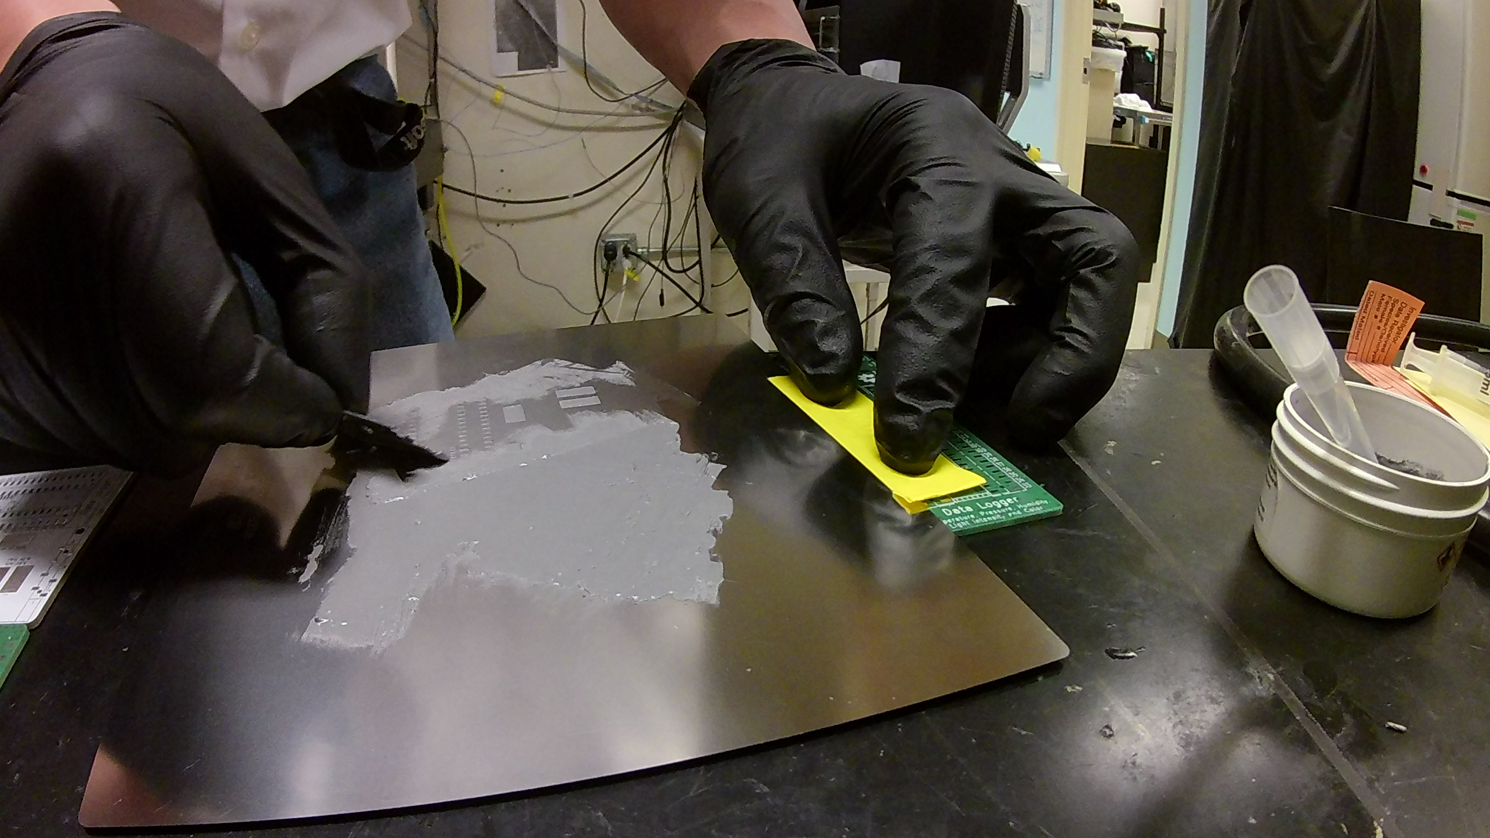

# Step 8: Lift the stencil from the PCB board

Once all of the excess paste is removed from the stencil, lift the stencil from the PCB by pulling up on the side opposite the tape. Once the stencil is clear of the PCB, carefully remove the tape from the stencil and PCB. Inspect the PCB to make sure all the pads are covered in solder paste, and then properly dispose of the blade and stirrer, and clean the stencil thoroughly with 70% ethanol or rubbing alcohol. Also return the solder paste to 4°C storage.

